**Serialized Data**

1. **Title Description:**

Build a get Api which returns a serialized data from 3 models which are connected through F.K.

1. **Task Screenshots:**

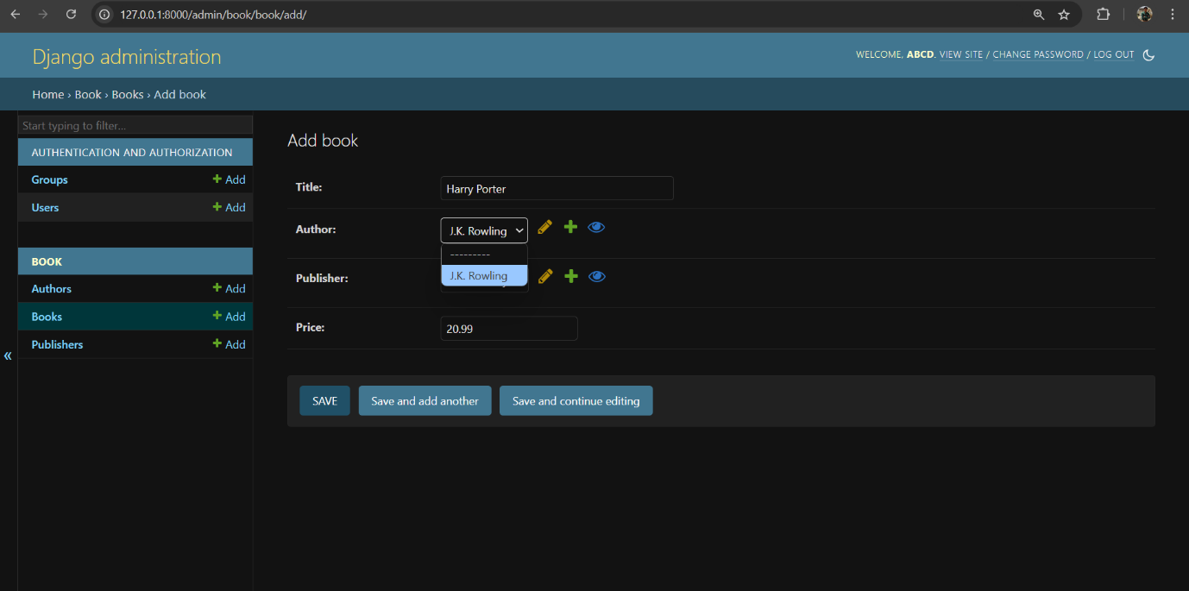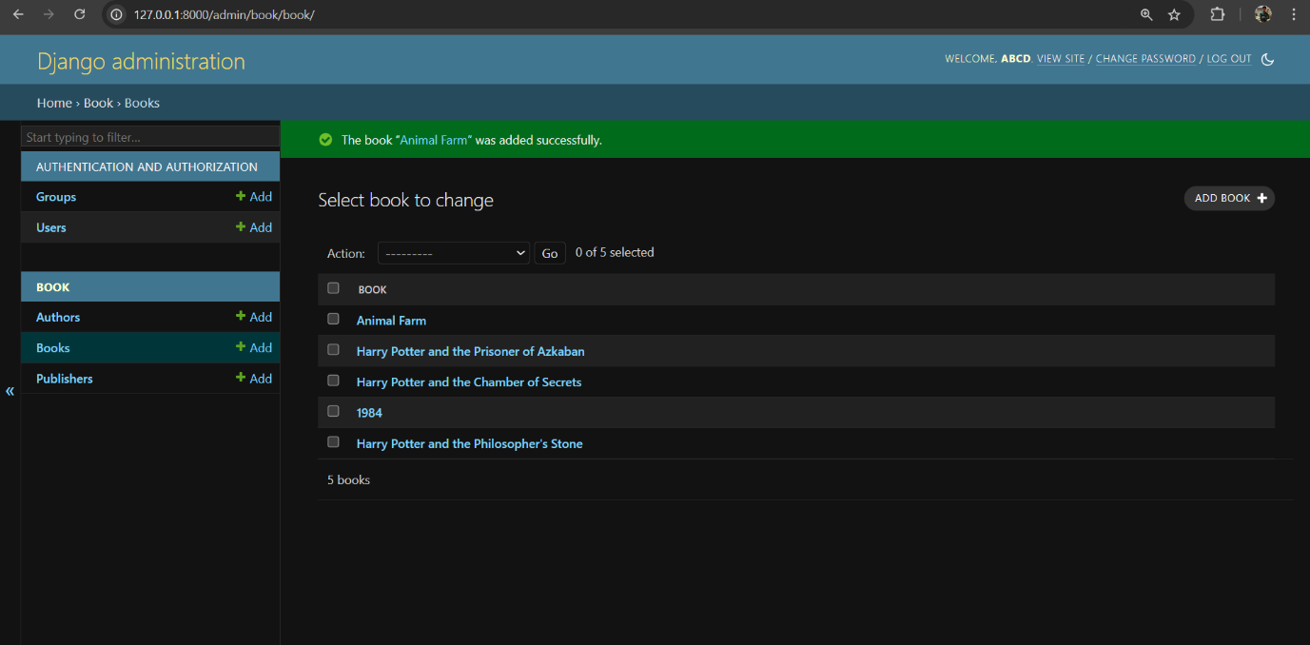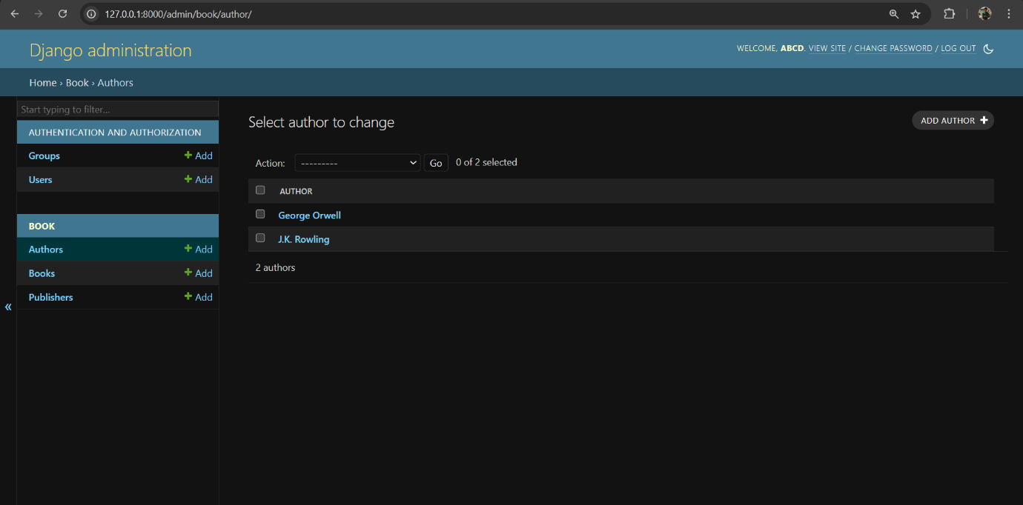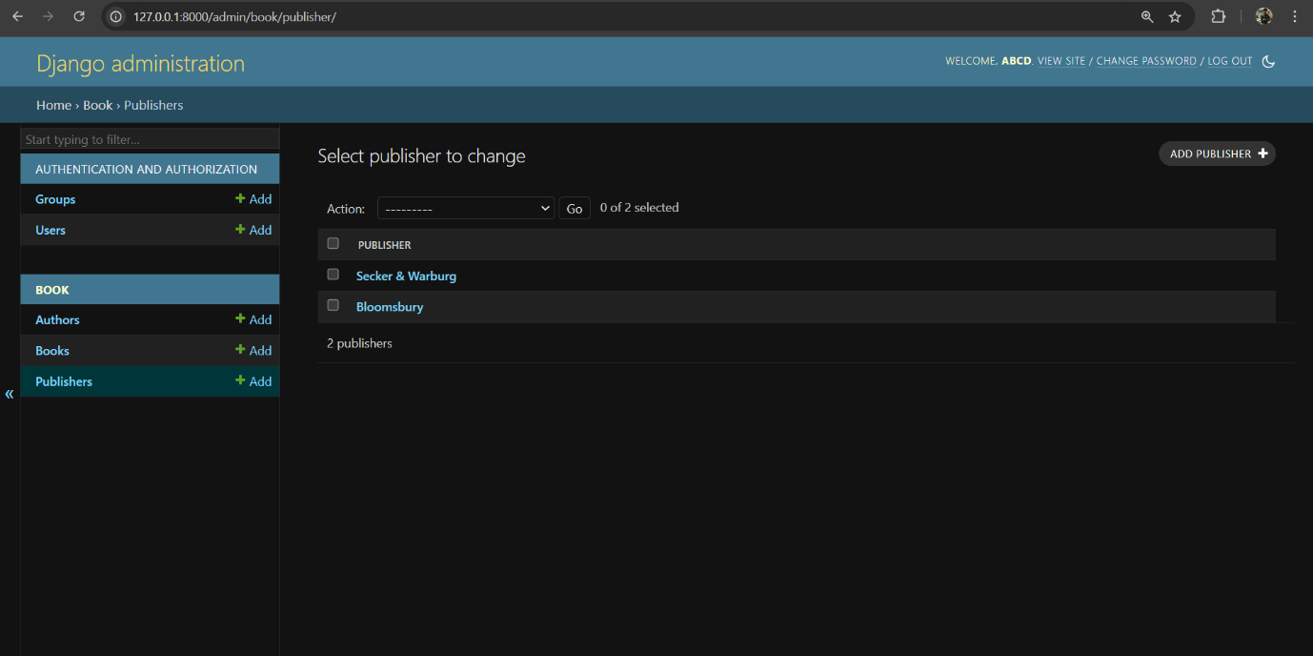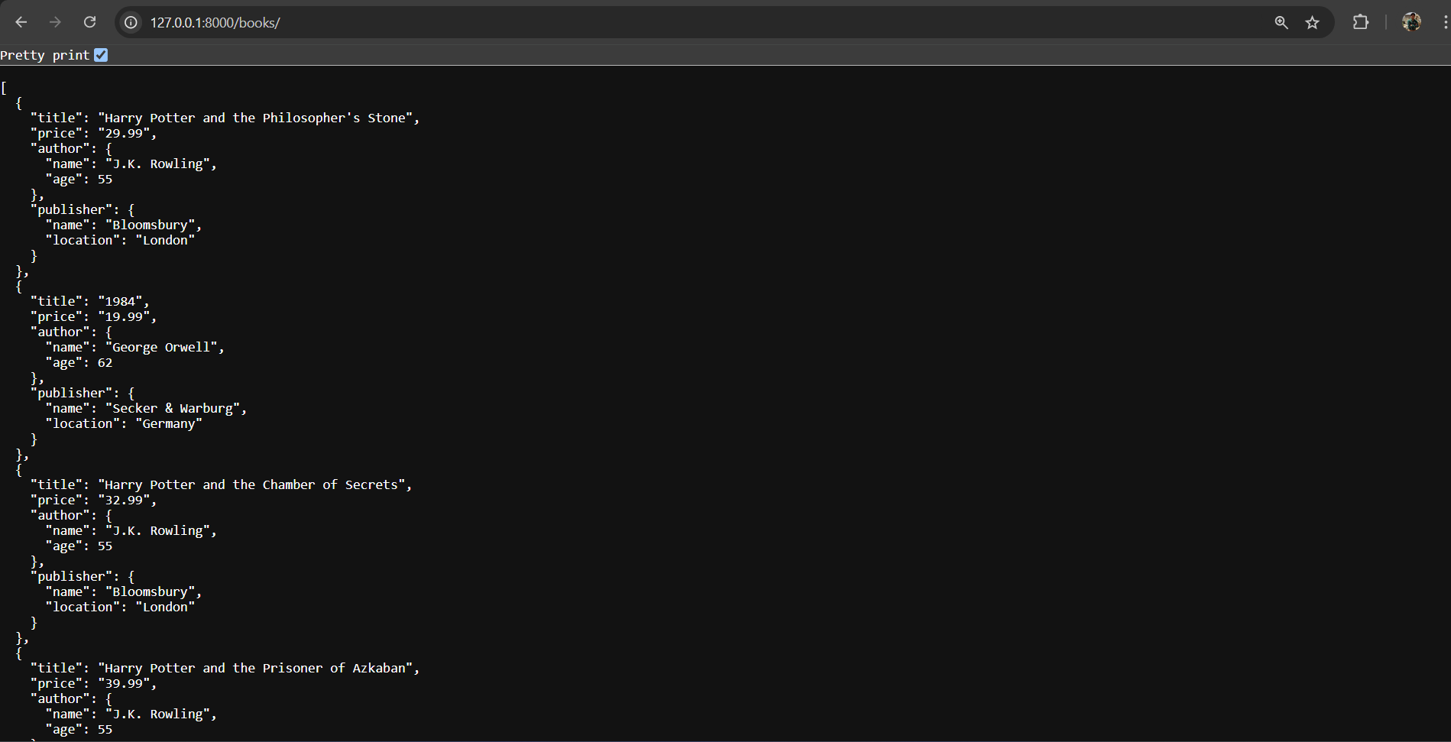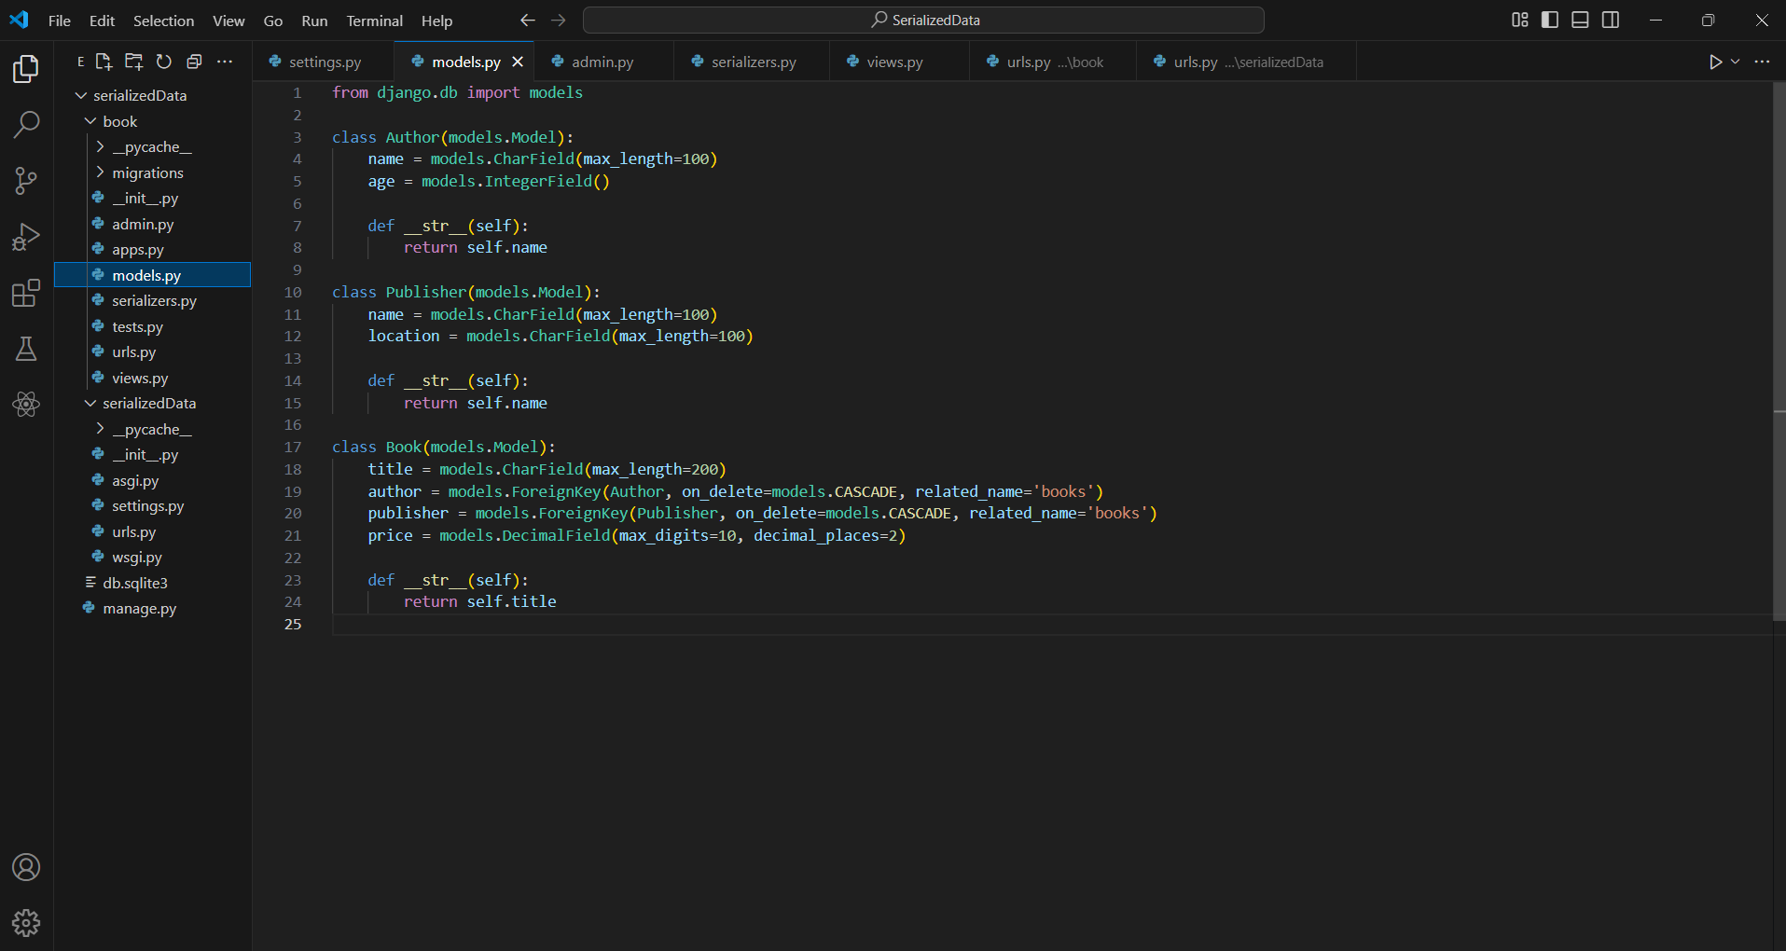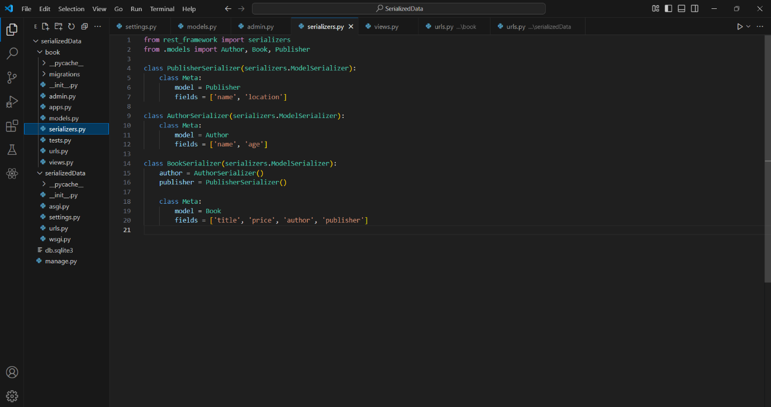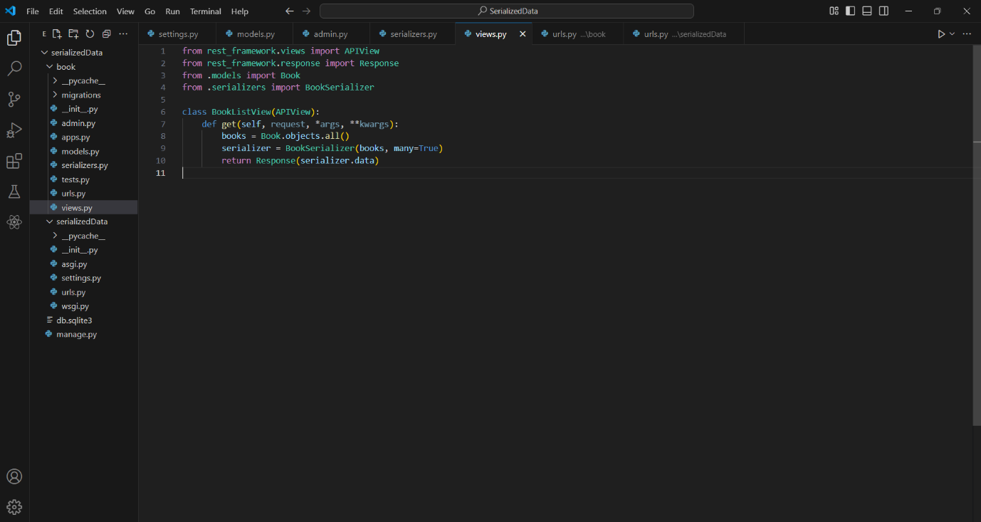

1. **Algorithm Used:**

* Created 3 models Book, Author, Publisher.
* In book model there is 2 foreign key one is of author which is from Author model and another is of publisher which is from Publisher model.
* Created 3 serializers.
* Used Rest-API to print the data in json format.